MANUAL HYPERPARAMETER SELECTION FORM
2D CNN Model — Dogs vs. Cats Image Classification
Name: Federico M. Griño
Program: DIT
Use this form to record, justify, and approve each hyperparameter value chosen by hand before a training run. The "Notebook Default" column shows the value currently used in Loading_Dataset_and_CNN.ipynb for reference — enter the value actually used for this run under "Chosen Value", even if it matches the default.

1. Project / Experiment Information
Project / Experiment Title | 2D CNN Model - Dogs vs. Cats Image Classification
Model Architecture | 2D Convolutional Neural Network (Conv2D)
Dataset Used | Kaggle Dogs vs. Cats images (Dog/ and Cat/ folders)
Notebook / File Reference | Loading_Dataset_and_CNN.ipynb
Prepared By | Federico M. Griño
Date | September 17, 2026
Experiment / Trial No. | 3 trials

2. Data Preprocessing Parameters
Hyperparameter | Options / Range Considered | Notebook Default | Chosen Value | Justification
Image Size (IMG_SIZE, square) | e.g. 50 / 80 / 100 / 128 / 150 | 100 | Trial 1: 50  Trial 2: 80  Trial 3: 100
Color Mode | Grayscale / RGB | Grayscale | Trial 1-3: Grayscale
Pixel Normalization | X/255.0 / none | X/255.0 | X/255.0
Shuffle Training Data | Yes / No | Yes (random.shuffle) | Yes (random.shuffle)
Held-out Test Set (separate from training) | Yes / No | No (validation_split only) | Yes
Validation Split (of training set) | 0.0 - 0.3 | 0.2 | 0.2

3. Model Architecture Hyperparameters
Trial 1
Hyperparameter | Options / Range Considered | Notebook Default | Chosen Value | Justification | Training Accuracy | Validation Accuracy
Conv2D Layer 1 – Filters | 16 / 32 / 64 / 128 | 14 |  |  | Trial 1: 0.6510  Trial 2: 0.7343  Trial 3: 0.5704 | Trial 1: 0.6302  Trial 2: 0.7165  Trial 3: 0.5500
Conv2D Layer 1 – Kernel Size | (3,3) / (5,5) | (3,3) | (3,3) |  | Trial 1: 0.6510  Trial 2: 0.7343  Trial 3: 0.5704 | Trial 1: 0.6302  Trial 2: 0.7165  Trial 3: 0.5500
Conv2D Layer 1 – Activation | relu / tanh / elu / leaky_relu | relu | relu |  | Trial 1: 0.6510  Trial 2: 0.7343  Trial 3: 0.5704 | Trial 1: 0.6302  Trial 2: 0.7165  Trial 3: 0.5500
Pooling Layer 1 – Type & Pool Size | MaxPooling2D / AveragePooling2D; (2,2) / (3,3) | MaxPooling2D, (2,2) | MaxPooling2D, (2,2) |  | Trial 1: 0.6510  Trial 2: 0.7343  Trial 3: 0.5704 | Trial 1: 0.6302  Trial 2: 0.7165  Trial 3: 0.5500
Dense (Fully Connected) Units | 16 / 32 / 64 / 128 | 64 | 64 |  | Trial 1: 0.6510  Trial 2: 0.7343  Trial 3: 0.5704 | Trial 1: 0.6302  Trial 2: 0.7165  Trial 3: 0.5500
Dropout Rate | 0.0 - 0.5 | None (not used) | None (0.0) |  | Trial 1: 0.6510  Trial 2: 0.7343  Trial 3: 0.5704 | Trial 1: 0.6302  Trial 2: 0.7165  Trial 3: 0.5500
Output Layer Activation | sigmoid (binary) / softmax (multi-class) | sigmoid | sigmoid |  | Trial 1: 0.6510  Trial 2: 0.7343  Trial 3: 0.5704 | Trial 1: 0.6302  Trial 2: 0.7165  Trial 3: 0.5500

4. Training Hyperparameters
Hyperparameter | Options / Range Considered | Notebook Default | Chosen Value | Justification | Training Accuracy | Validation Accuracy
Loss Function | binary_crossentropy / categorical_crossentropy | binary_crossentropy | binary_crossentropy |  | Trial 1: 0.6510  Trial 2: 0.7343  Trial 3: 0.5704 | Trial 1: 0.6302  Trial 2: 0.7165  Trial 3: 0.5500
Optimizer | adam / sgd / rmsprop | adam | adam |  | Trial 1: 0.6510  Trial 2: 0.7343  Trial 3: 0.5704 | Trial 1: 0.6302  Trial 2: 0.7165  Trial 3: 0.5500
Learning Rate | 0.1 / 0.01 / 0.001 / 0.0001 | 0.001 (Adam default) | 0.001 (Adam default) |  | Trial 1: 0.6510  Trial 2: 0.7343  Trial 3: 0.5704 | Trial 1: 0.6302  Trial 2: 0.7165  Trial 3: 0.5500
Batch Size | 8 / 16 / 32 / 64 / 128 | 32 | 128 |  | Trial 1: 0.6510  Trial 2: 0.7343  Trial 3: 0.5704 | Trial 1: 0.6302  Trial 2: 0.7165  Trial 3: 0.5500
Number of Epochs | e.g. 10 - 200 | 200 | 10 |  | Trial 1: 0.6510  Trial 2: 0.7343  Trial 3: 0.5704 | Trial 1: 0.6302  Trial 2: 0.7165  Trial 3: 0.5500
Early Stopping | Yes (patience = ___) / No | No | No |  | Trial 1: 0.6510  Trial 2: 0.7343  Trial 3: 0.5704 | Trial 1: 0.6302  Trial 2: 0.7165  Trial 3: 0.5500

5. Evaluation Results (after training with chosen values) - Final Model
Metric | Value Obtained | Target / Acceptable Range
Training Accuracy | Trial 1: 0.6302, Trial 2: 0.7343, Trial 3: 0.5704
Validation Accuracy | Trial 1: 0.6302, Trial 2: 0.7165, Trial 3: 0.5500
Test Accuracy | Trial 1: 0.6218, Trial 2: 0.7063, Trial 3: 0.5600
Test Loss | Trial 1: 0.6708, Trial 2: 0.5782, Trial 3: 0.6857
Precision / Recall / F1 (macro avg) | Trial 1: 0.6733, 0.6218, 0.5914  Trial 2: 0.7254, 0.7094, 0.7041  Trial 3: 05784, 0.5600, 0.5326

5. a. Paste here all screenshots/figures of the tuned model
Training 1: Localhost Run, Image Size 50, Epoch 10
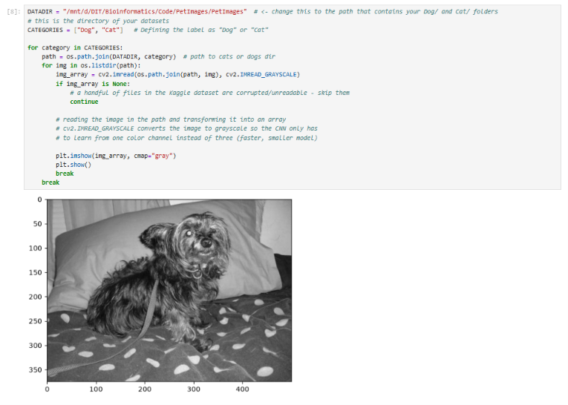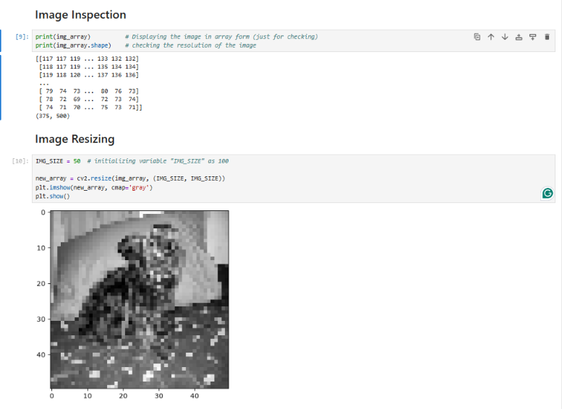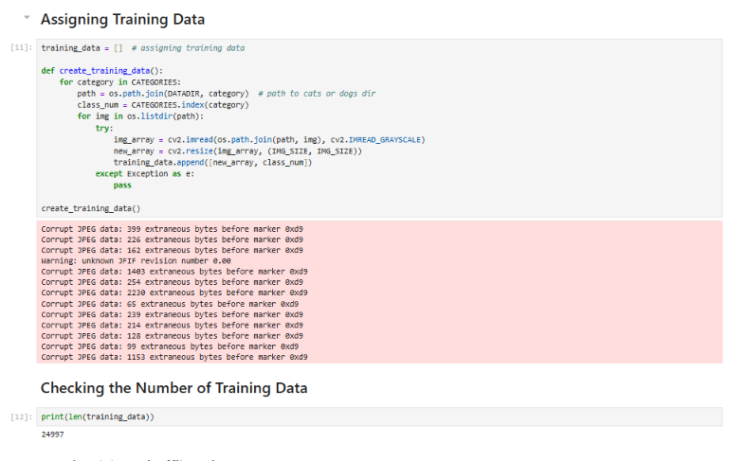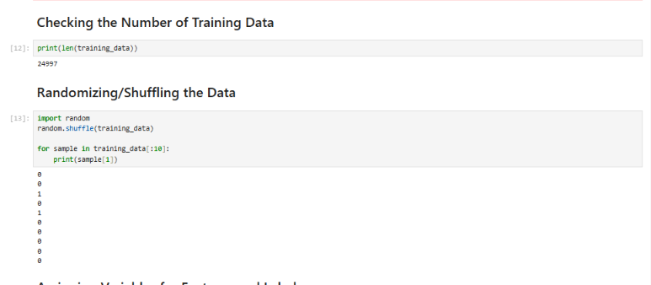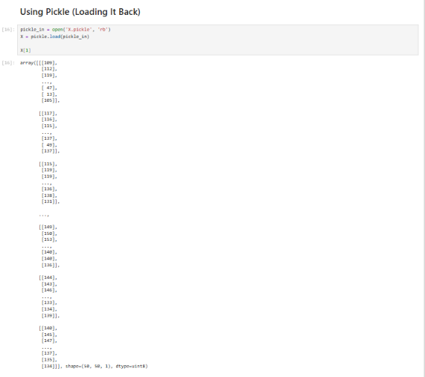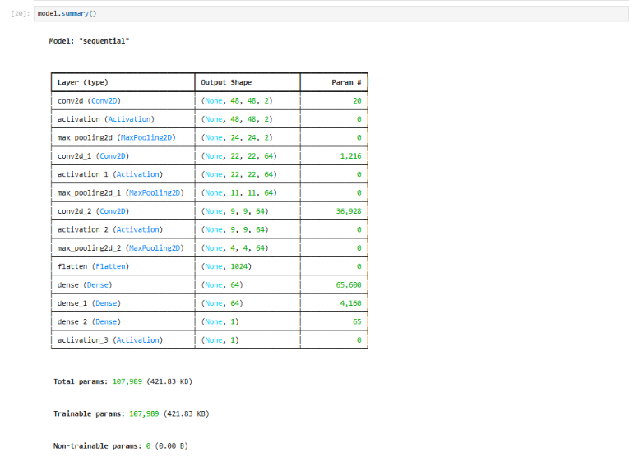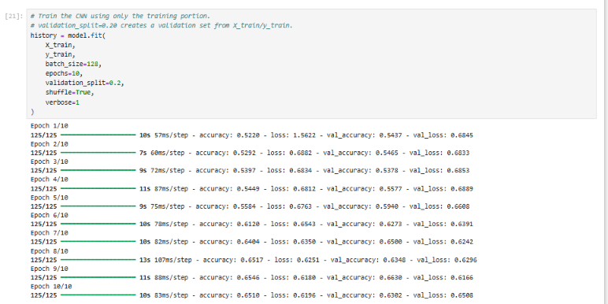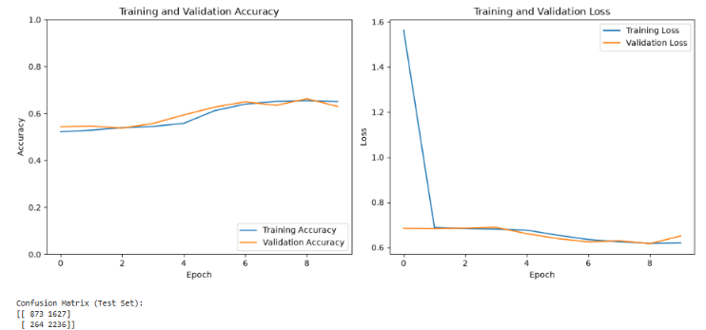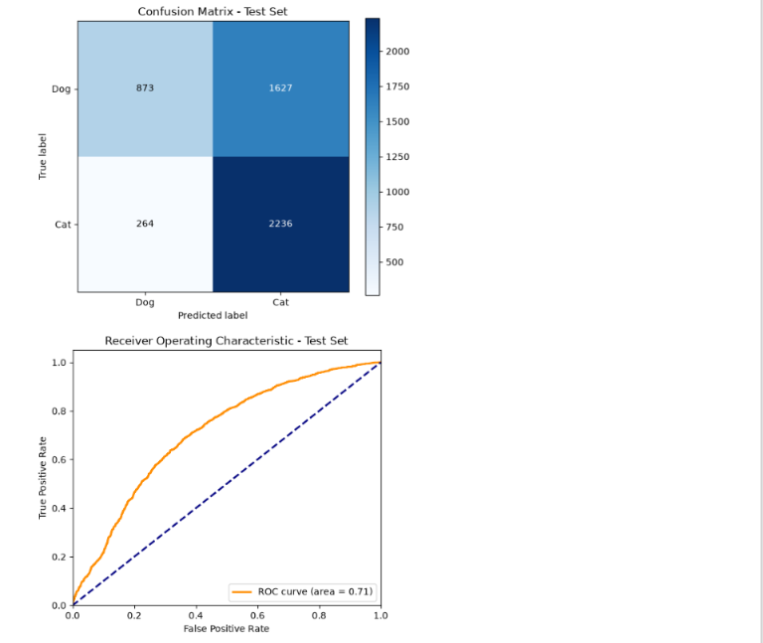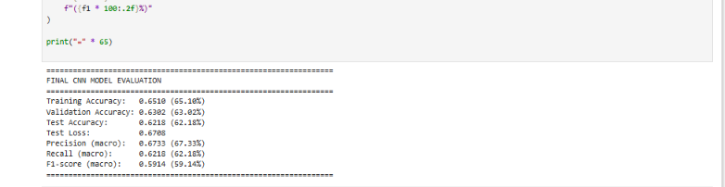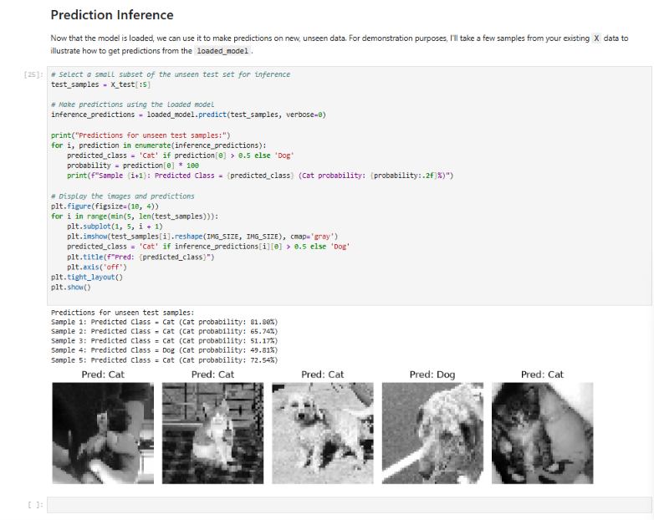

Training 2: Localhost Run, Image Size 80, Epoch 10

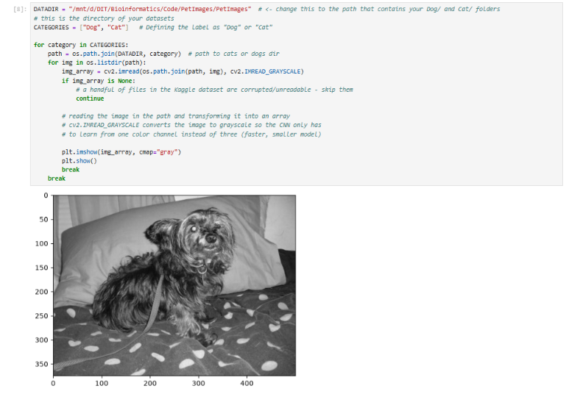
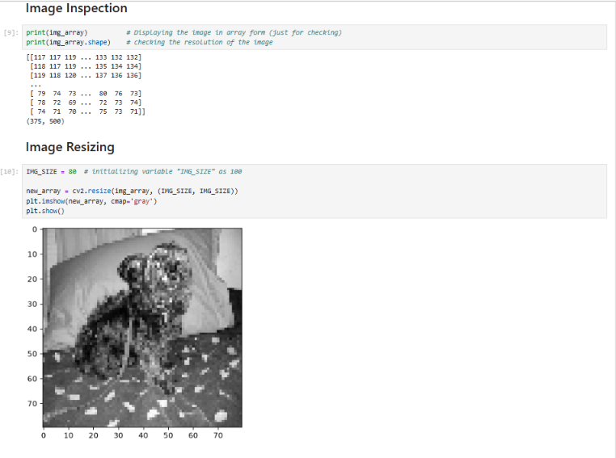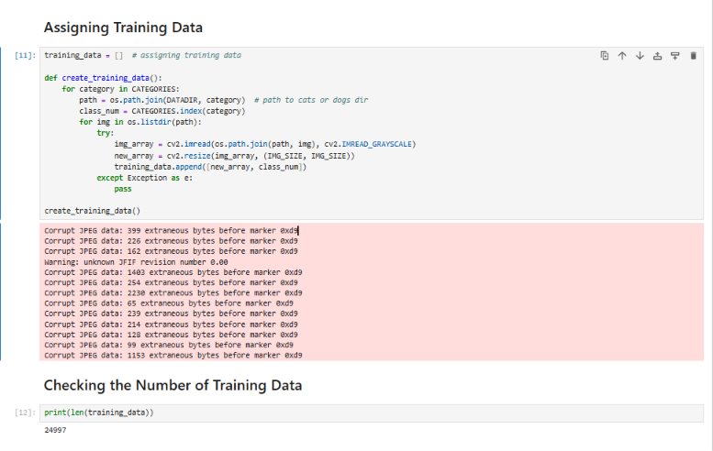
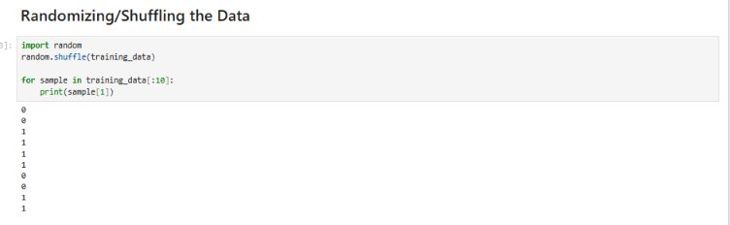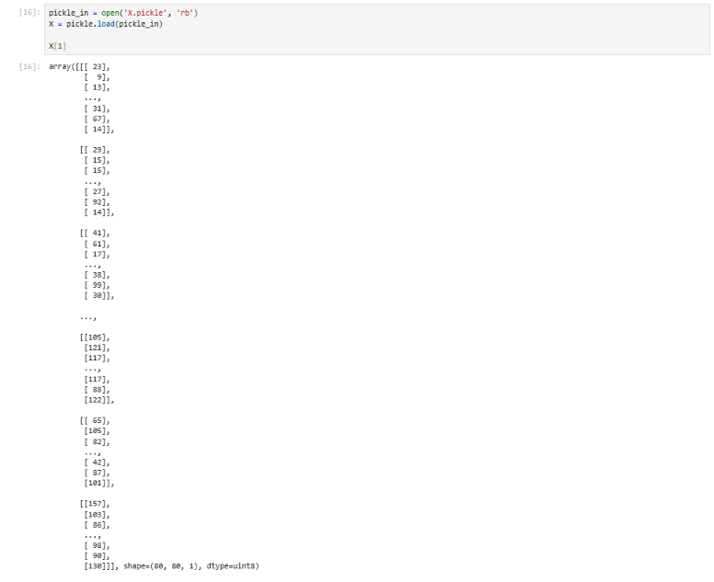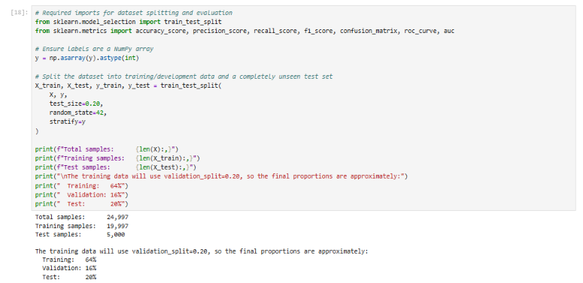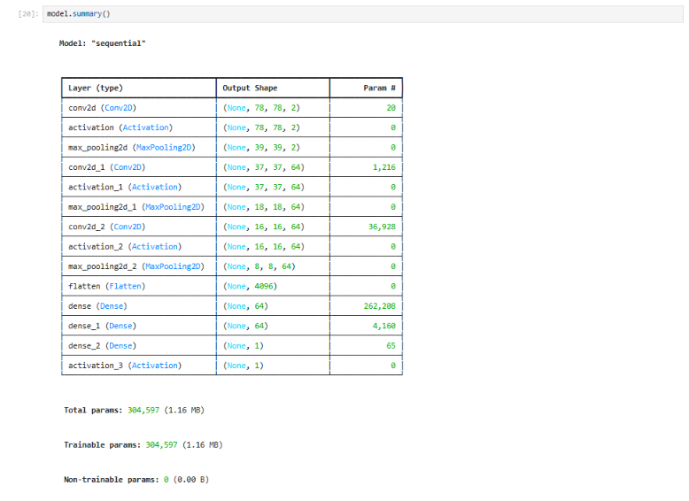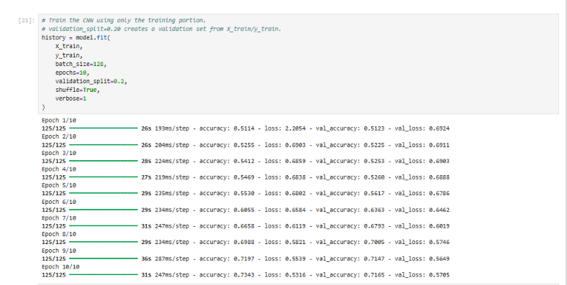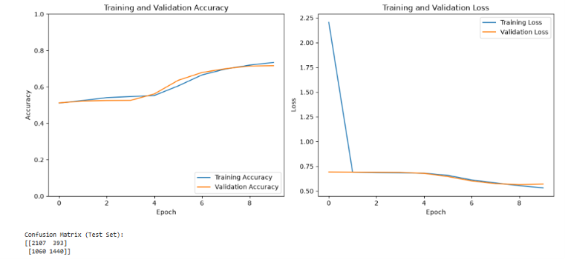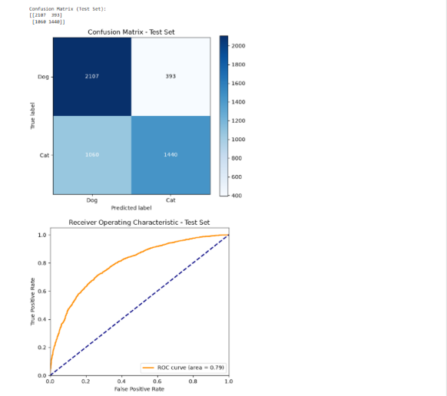

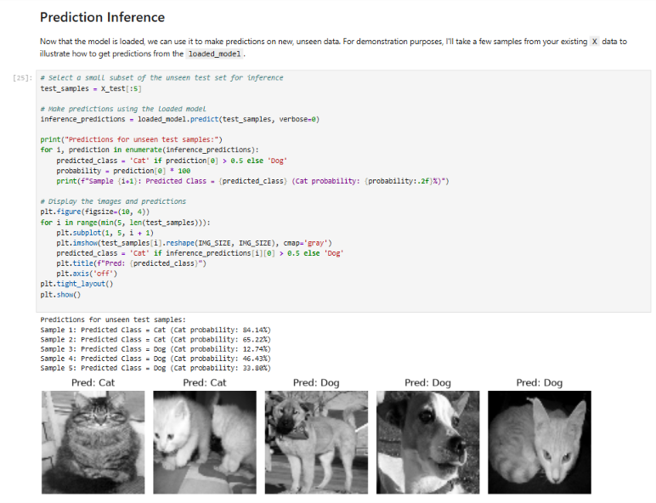

Training 3: Localhost Run, Image Size 100, Epoch 10

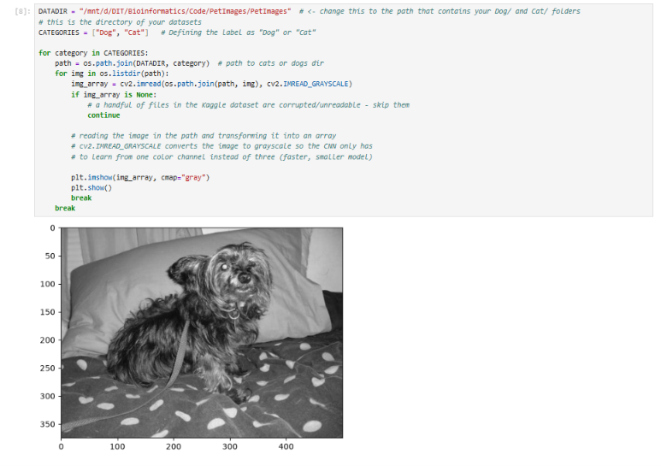
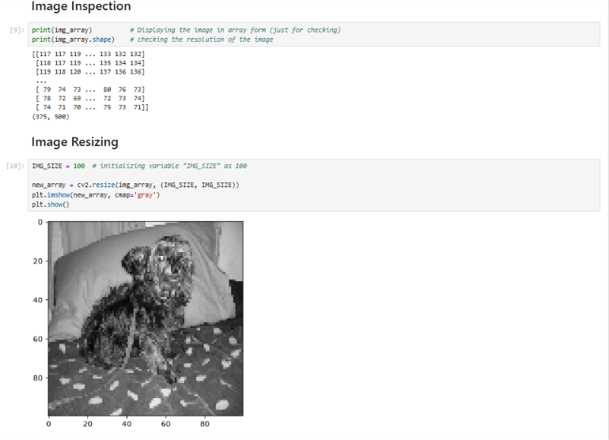
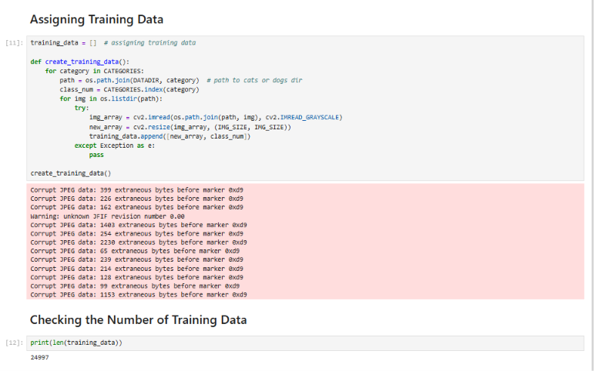

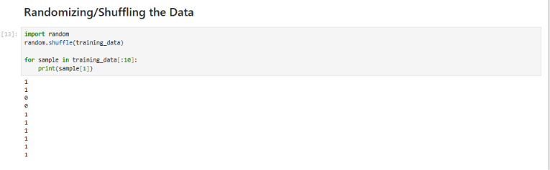
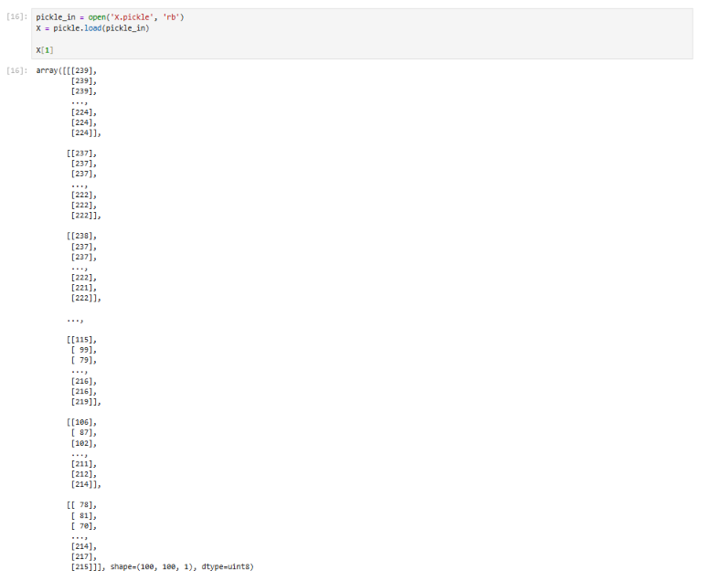
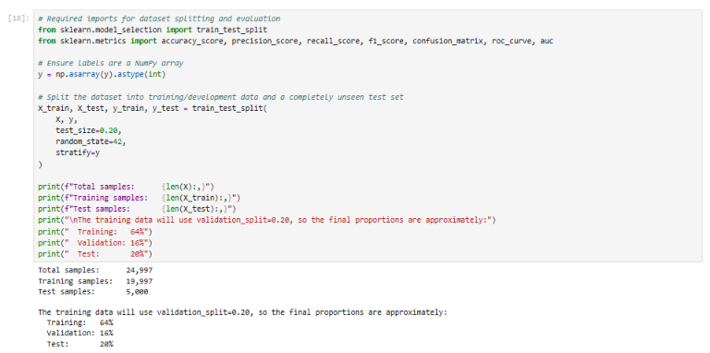
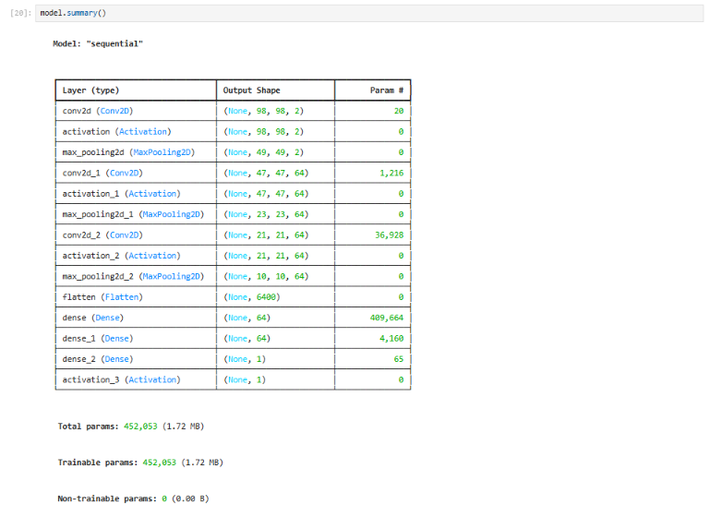

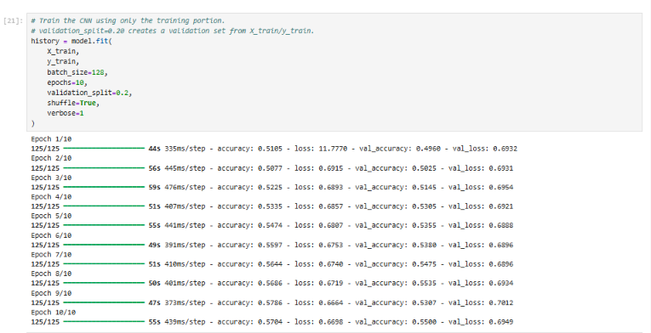

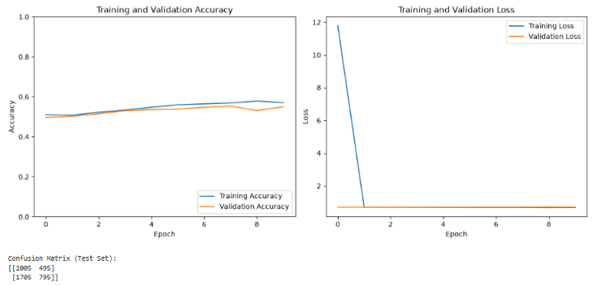
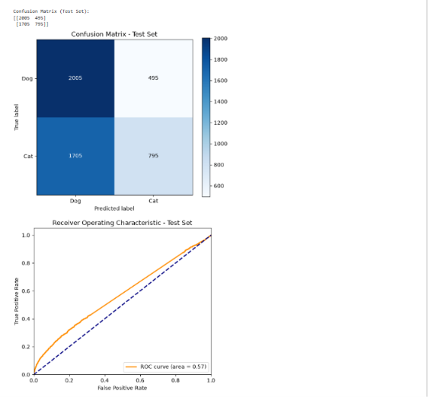
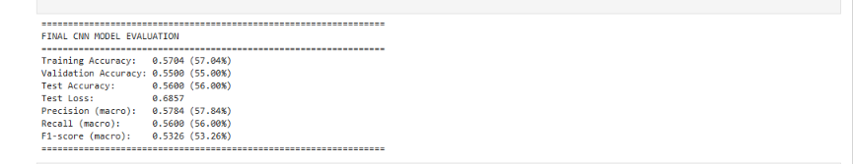

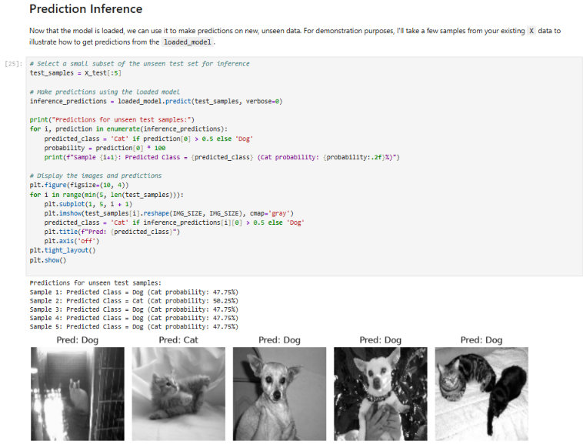

6. Overall Justification / Remarks
Three manual trials were conducted using grayscale input sizes of 50 × 50, 80 × 80, and 100 × 100 pixels. The other recorded settings were retained across the trials, including pixel normalization (X/255.0), a 3 × 3 convolution kernel, ReLU and max-pooling layers, a 64-unit dense layer, a one-unit sigmoid output, binary cross-entropy, the Adam optimizer with a learning rate of 0.001, batch size 128, and 10 training epochs. The documented data partition uses a stratified 20% held-out test set and a 20% validation split of the remaining training data (approximately 64% training, 16% validation, and 20% test). This controlled comparison provides a basis for examining the effect of input image size under the recorded training setup.
Among the three reported trials, Trial 2 (80 × 80 pixels) achieved the highest recorded validation accuracy (0.7165) and test accuracy (0.7063), the lowest recorded test loss (0.5782), and the highest reported macro F1-score (0.7041). Accordingly, the 80 × 80 configuration is the preferred choice among the three tested image sizes for this experiment. This finding applies to the documented dataset split, architecture, and training settings; it does not establish that 80 × 80 pixels is universally optimal for dogs-versus-cats classification.

Summarize why this combination of hyperparameters was chosen (e.g., prior trial results, literature basis, computational constraints) and any observations (overfitting, underfitting, convergence issues).

